**3GPP TSG RAN WG1 Meeting #114 R1-2306873**

**Toulouse, France, August 21st – August 25th , 2023**

**Agenda Item: 9.5.2 NR DL and UL carrier phase positioning**

**Source: Locaila, Inc**

**Title: Remaining issues on NR DL and UL carrier phase positioning**

**Document for: Discussion & Decision**

# Introduction

According to Rel-18 new work item on expanded and improved NR positioning, the following aspects are considered within the scope of work hence they are discussed in relation to carrier phase positioning (CPP). In this contribution, we provide proposals associated with the topics.

# Discussion on standalone approach (i.e. Integer Ambiguity Solution)

In the previous meeting, there was a debate regarding the support for a standalone approach in relation to CPP's Integer Ambiguity Solution, and no conclusion has been reached yet.

As we understand it, the standalone approach refers to determining the UE's location solely based on CPP's phase measurement results. On the other hand, the non-standalone approach requires the application of other timing-based legacy measurement methods such as ToA/TDoA/RTT to identify the unknown integers of CPP.

We believe that for the CPP method, there is no need for legacy measurements or virtual carrier methods. We argue that by utilizing only the subcarrier information of OFDM, we can obtain the complete solution for the unknown integers, enabling us to determine the initial UE location as well as improve positioning for UL/DL/Sidelink. The feasibility of this standalone CPP method has been demonstrated through our actual field experiments [5]. And in R1-2206227 [8], we presented an exact solution for determining the unknown integers using the subcarrier information, as (1) below.

(1)

$$N=\left\lfloor f_{c}/f_{q}∙ϕ_{s}/2π-ϕ_{c}/2π\right\rfloor$$

In the above exact solution (1), ***fc*** represents the carrier frequency, **𝜙c** represents the measured carrier phase, ***fq*** represents the subcarrier frequency, and **𝜙s** represents the measured subcarrier phase. ⌊ ⌋ denotes the floor function. (***fc/fq***) represents the ratio of the carrier wavelength to the subcarrier wavelength, and **𝜙s/2𝜋** and **𝜙c/2𝜋** are the normalized subcarrier and carrier phase measurement values, respectively, ranging from 0 to 1 (or -0.5 to +0.5). The mathematical derivation of (1) is described in Appendix-A.

According to the discussions in the RAN1 #110 meeting, UE is required to report the minimum legacy timing measurement results along with RSCP/RSCPD values. This seems to be an attempt to estimate the unknown integers of NR CPP using the initial UE positioning information. However, in our view, this is unnecessary.

In GPS methods, since the exact solution for the unknown integers is not known, it is required to narrow down the search space of potential candidates for the unknown integers iteratively using the initial UE positioning information. This search space can sometimes be extensive, requiring the examination of thousands of candidates. To mitigate this inefficiency, methods like the Widelane approach, which uses two or more frequencies, are employed to reduce the search space. Some companies in 3GPP also suggest this GPS-like widelane method (a.k.a virtual carrier method) to estimate the unknown integers in NR CPP.

However, in NR OFDM, which is technically more advanced than GPS, the phase information of the longer wavelength subcarriers can be used to estimate exact integer number using the formula (1). In other words, whether applying the legacy method or using the virtual carrier method, the unknown integer that eventually converges will be the value obtained by Equation (1).

**(Observation 1) The standalone approach which utilizes subcarrier information can provide the complete solution of an unknown integer number.**

**(Proposal 1) Support the standalone approach for integer ambiguity which uses multiple subcarrier phase information.**

According to the virtual carrier solution introduced in [9][10][11], it can be summarized as follows.

------------------------ excerpted from R1-2303890 ZTE discussion -----------------------

The scope of integer searching with differential carrier phase(s), i.e., using virtual wavelength, can be minimized (or be zero), which will reduce the computation complexity of location de-composition. As shown in the following figure, if we divide a PFL into 2 sub-PFL, the corresponding location estimation can be determined as follows:



Figure 1. Division of single PFL into 2 sub-PFL

 

λ is the wave length of radio signal, Φ is the fractional part of carrier phase estimation, ΦDrift is the carrier phase error, N is the integer part of carrier phase, d is the real distance between UE and gNB (LOS distance). Combining these two equation, we have:



If the above equation is multiplied by a virtual wave length $λ_{v}=1/(1/λ_{2}-1/λ_{1})$, there will be



Where, the ΔΦ=Φ2-Φ1, ΔN=N2-N1 .

It can be observed that, the carrier phase error (ΦDrift) from two frequency sections in one carrier within one site (or one gNB) is removed by single difference. And also, if the frequency difference of two sub-carriers are small enough, the scope of integer searching with differential carrier phase(s)ΔN can be minimized (or be zero). The computational complexity can be minimized.

-----------------------------------------------------------------------------------------

The main concept of the virtual carrier method described above is to calculate the phase difference *ΔΦ*, which is determined by the frequency difference between the two sub-PFLs, i.e., the phase difference measured by the subcarrier with a wavelength of ***λv***. Although the effort to find the result of the ***ΔN*** (=N2-N1) calculation is reduced, it still needs to find the values of ***N1*** and ***N2*** that satisfy ***ΔN***. This can be one of many possible values in hundreds of cases.

On the other hand, using the standalone method, we can directly find not only ***ΔN*** but also the unknown integer number ***N1, N2*** using Equation (1). Additionally, by applying the standalone method, we can calculate the desired ***ΔΦ*** values required by the virtual carrier method.

Let ***Y*** be the set of subcarriers consisting of a single PFL in the figure above. ***Y*** can be seen as a set of complex exponentials extracted from the REs comprising the PRS after the FFT operation. In (2) below, ***m*** represents the number of elements in ***Y***, i.e., the number of PRS REs.

(2)

$$Y=\left\{x_{1},x_{2},…,x_{m}\right\}$$

The virtual carrier method described above divides the set ***Y*** into two equal-sized subsets, ***Y1*** and ***Y2***, as follows:

(3)

Now, for each subset ***Y1*** and ***Y2***, if we calculate the phase *Φ2* and *Φ1* for the center frequency, we can obtain the phase difference ΔΦ (= Φ2 - Φ1), which is the value we want to calculate in the virtual carrier method. This process is represented by Equation (4), which uses the subset representation in Equation (3).

(4)

$$ΔΦ=Φ_{2}-Φ_{1}=arg\left(sum\left(Y_{2}\right)-sum\left(Y_{1}\right)\right)$$

In Equation (4), ***sum(Y1)*** and ***sum(Y2)*** are expressions that calculate the center frequency by summing the elements of each subset. The ***arg(..)*** function calculates the phase difference ΔΦ (= Φ2 - Φ1) between the two center frequencies. Therefore, Equation (4) can be seen as the formula for calculating the phase difference value ΔΦ based on the virtual carrier method described in [9][10][11].

Now, let's transform Equation (4) into the form of the sum of complex differences for each element in subsets ***Y1*** and ***Y2***, as shown in Equation (5).

(5)

$${ΔΦ}_{m/2}=arg\left(sum\left\{\left(x_{m/2+1}-x_{1}\right),\left(x_{m/2+2}-x_{2}\right), … , \left(x_{m}-x_{m/2}\right)\right\}\right)$$

Equation (5) is mathematically equivalent to Equation (4). Equation (5) represents the standalone method for calculating the phase of a subcarrier with a wavelength of ***λv*** (=***λ2 - λ1***). In other words, for the special case where the sub-PFL is half the size of the total PFL, both the virtual carrier method and the standalone method yield the same result. Therefore, the standalone method can also calculate the ΔΦ value required by the virtual carrier method.

To help understand the standalone method, below table 1 presents various methods of dividing the subset ***Y1*** and ***Y2***, similar to the PFL concept described in Figure 1.

|  |  |  |  |
| --- | --- | --- | --- |
|  | (a) ΔΦm-1 | (b) ΔΦm/2 | (c) ΔΦ1 |
| Subset  formulation |  |  |  |
| Subset Size | 1 | m/2 | m-1 |
| Subcarrier wavelength | shortest | middle | longest |
| Equation for ΔΦ | $${ΔΦ}_{m-1}=arg\left(x_{m}-x_{1}\right)$$ | $${ΔΦ}_{m/2}=arg\left(sum\left\{\left(x_{m/2+1}-x_{1}\right),\left(x_{m/2+2}-x_{2}\right), … , \left(x_{m}-x_{m/2}\right)\right\}\right)$$ | $${ΔΦ}_{1}=arg\left(sum\left\{\left(x_{2}-x_{1}\right),\left(x_{3}-x_{2}\right), … , \left(x_{m}-x_{m-1}\right)\right\}\right)$$ |

Table 1 Various sizes of subsets and calculation methods for the subcarrier phase in standalone method

The standalone method can be described as the process of dividing ***Y*** into various sizes of two subsets, as in cases (a), (b), and (c) in Table 1, and performing phase difference operations between them.

In Table 1 (a), two subsets consisting of two subcarrier elements each at the ends of the PFL (i.e., set ***Y***) are created, and the phase difference between these subcarriers is calculated. In Table 1 (b), ***Y*** is divided into subsets of 1/2 size, similar to Figure 1. Table 1 (c) represents ***Y*** divided into two subsets with ***(m-1)*** upper subset and ***(m-1)*** lower subset allowing duplication of some elements.

In Table 1 (c) , the complex phase differences between these two ***(m-1)*** size subsets can be calculated and vector summed, as shown in equation (6).

(6)

The ΔΦ1 in equation (6) represents the calculated phase difference using the longest wavelength subcarrier. The frequency of this subcarrier corresponds to the gap frequency between RE and RE in the comb-N PRS structure. If the wavelength of this subcarrier is longer than twice the distance between the two TRPs that transmitted the PRS, ΔΦ1 does not exceed the range of -π ~ +π. In other words, no unknown integer arises, so the phase difference value can be directly converted to a distance difference to calculate ToA/TDoA values and determine the initial UE location. Therefore, even without separately applying the legacy time measurement method, timing information can be obtained using only the standalone phase information.

In Table 1, case (b) represents the method of dividing PFL into two subsets of 1/2 size, as explained earlier. This is equivalent to the virtual carrier method shown in Figure 1. Therefore, using the standalone method, ΔΦ (= Φ2-Φ1) can be calculated. Note that the virtual carrier method requires iterative operations to estimate ***N1*** and ***N2*** that satisfy the unknown integer ***ΔN*** (=N2-N1). However in the standalone method, with the calculated two subcarrier phase values ΔΦ1 and ΔΦm/2 using equations (5) and (6), the unique solution of the unknown integer ΔNm/2 can be obtained as below (7).

(7)

$${ΔN}_{m/2}=\left\lfloor (m/2)∙{ΔΦ}_{1}/2π-{ΔΦ}_{m/2}/2π\right\rfloor$$

In Table 1 (a), ΔΦm-1 represents the phase difference between subcarriers located at the ends of PFL (i.e., set Y), calculated using the difference in subcarrier frequencies, as (8) below. This subcarrier frequency corresponds to the frequency of the entire bandwidth of PFL, and it is the shortest-length subcarrier close to the carrier wavelength.

(8)

$${ΔΦ}_{m-1}=arg\left(x_{m}-x_{1}\right)$$

$${ΔN}_{m-1}=\left\lfloor (2-2/m)∙{ΔΦ}_{m/2}/2π-{ΔΦ}_{m-1}/2π\right\rfloor$$

Equation (9) below utilizes the phase information ΔΦm-1 of (8) to estimate the integer number of carrier phase. If we denote the carrier phase difference measured with the center frequency of PFL as ΔΦc, the final expression for the integer number of carrier phase can be expressed as follows:

(9)

$$N_{1}=\left\lfloor (f_{c}/f_{m-1})∙{ΔΦ}_{m-1}/2π-{ΔΦ}_{c}/2π\right\rfloor$$

In Equation (9), ***fc*** represents the carrier frequency, and ***fm-1*** corresponds to the subcarrier frequency associated with the phase difference ΔΦm-1. However, to obtain the solution in Equation (9), we need to know the value of ΔΦm-1 first, which requires computing ΔNm-1. Similarly, to solve ΔΦm/2 in Equation (5), we need to calculate ΔNm/2 first. Therefore, a series of preprocessing operations are necessary to solve the integer ambiguity in Equation (9), requiring multiple subcarrier phase information such as ΔΦ1 , ΔΦm/2, ΔΦm-1, … in decreasing order of wavelength. In fact, the more diverse lengths of subcarrier phase information UE reports, the more accurate the estimation of the integer number becomes.

In conclusion, the standalone method is a way to calculate the unique solution of the integer ambiguity using the subcarrier structure of OFDM. The virtual carrier method is a special case of the standalone method, so it can be sufficiently supported using the reported subcarrier information.

**(Observation 2) By applying the standalone method, we can obtain a unique solution to the integer ambiguity and perform CPP efficiently. Therefore, it is necessary to support the reporting of multiple subcarrier phase or phase difference information.**

Therefore, we propose the following text that integrates all the discussions

**(Proposal 2) *For resolving integer ambiguity, subject to UE’s capability, support LMF to request a UE reporting mean value of carrier phase differentials across N subcarriers within a PFL.***

* ***FFS: the value(s) of N***
* ***Note: The initial reference for the carrier phase differentials is a reported RSCP.***

**3. Study on oscillator quality and TRP synchronization**

**3.1 Motivation and objective of the study**

In the last #112bis-e meeting, following study one the TRP synchronization method by compensating for the initial phase offset error between TRPs are suggested to investigate.

* *RAN1 should study the benefit and efficiency of the proposed TRP synchronization method, and also the application of the curl-vector for removing initial phase offset errors between TRPs.*

During the past SI and WI discussion, we found that initial phase offset errors caused by the oscillator drift of gNB/TRPs had a significant impact on carrier phase measurements, but we do not know how much it will affect the accuracy.

We should study the effect of the oscillator quality on UL/DL carrier phase positioning. Further, aspects of the TRP synchronization method using PRS signal need to be studied as a solution. System impact and benefit to carrier phase positioning should be discussed. We encourage companies to participate in this study and bring their own.

The following issues should be investigated further in relation to this brief study.

* Measurement of the clock timing difference of TRPs
* Aspects related to monitoring PRS phases between TRPs
* Adjustment of PRS signal phases at the TX baseband using the curl-vector

**3.2 Discussion on oscillator quality and carrier phase measurement**

The carrier phase of the PRS signal transmitted by the TRPs varies depending on the performance of the internal oscillator. As a result, when comparing the carrier phase of PRS signals received from two or more TRPs, the phase difference fluctuates freely between -π ~ +π.

Figure 2 below illustrates the variation of the carrier phase difference observed over 5 minutes. Each graph represents the case of carrier frequencies of 1GHz, 2GHz, 3GHz, and 4GHz, respectively. The y-axis represents the radian scale of the phase difference in the range of -π ~ +π, while the x-axis represents a time duration of 300 seconds.

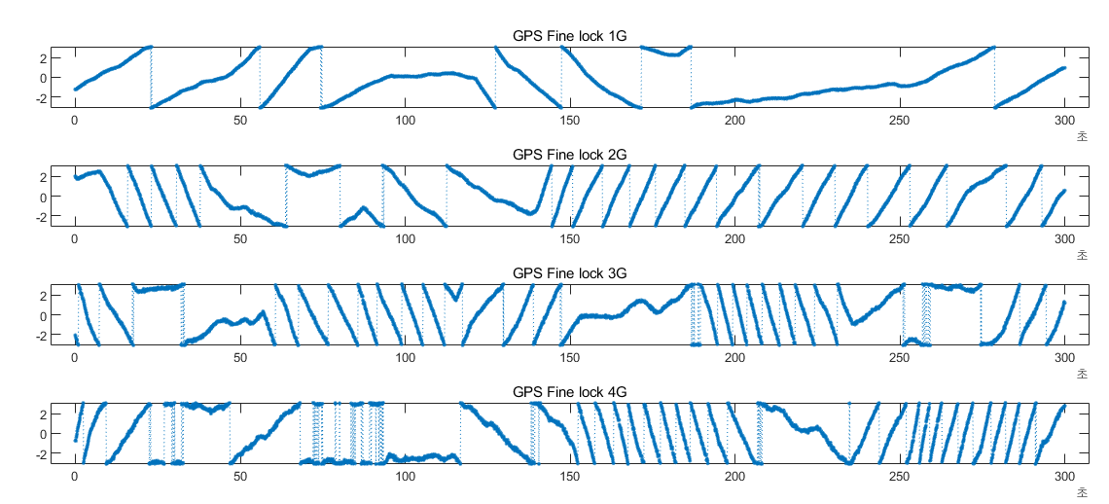

Figure 2: Phase difference in different carrier frequencies (5 min, GPSDO=0.04ppb)

The two gNBs generating the carrier signal were synchronized using GPSDOs (GPS Disciplined Oscillators) with a very precise stability of 0.04 ppb. This oscillator is 10-3 times more accurate than what has been assumed in TR38.859. However, even with such high-quality oscillators, the phase difference of PRSs can experience significant drift, which may severely affect measurement accuracy. This phenomenon is referred to as "initial phase offset error" in RAN1.

Currently, in 3GPP discussions, the PRU and double-difference method is being considered as post-compensation method for this initial phase offset error. This approach applies the double-differential method used in Differential Global Positioning System (DGPS) to the NR system. However, it has been observed that this method, as applied to 5G NR systems, has increasing impacts and costs, making the NR CPP more complex and slower. For instance, all UEs and PRUs may need to perform time stamping while conducting measurements, or UEs may have to wait for LMF (Location Measurement Function) to provide assistance information, or TRPs may need to individually specify the time for receiving PRS signals from UEs. Thus, the NR double-difference method has become more complex and inefficient compared to the DGPS method.

**3.3 Pre-compensation of phase offset in TRP**

In this section, a preprocessing method, contrast to post-compensating double-difference method, is introduced to synchronize the carrier phases in advance at the TRP before transmitting the PRS signal.

In order to synchronize the phases of PRS signals transmitted by multiple different TRPs, it is necessary to periodically observe the phases of PRS signals transmitted by neighboring TRPs. This can be achieved by allowing neighboring nodes to listen to the PRS signals during muting sequences in TDD mode.

For example in Figure 3 below, three neighboring gNBs/RSUs (A, B, C) operating in TDD mode simultaneously transmit PRS signals. gNB/RSU-B and C sometimes stop transmitting PRS signals during predetermined muting periods. Instead, they can receive the PRS signals transmitted by the neighboring gNB/RSU-A.

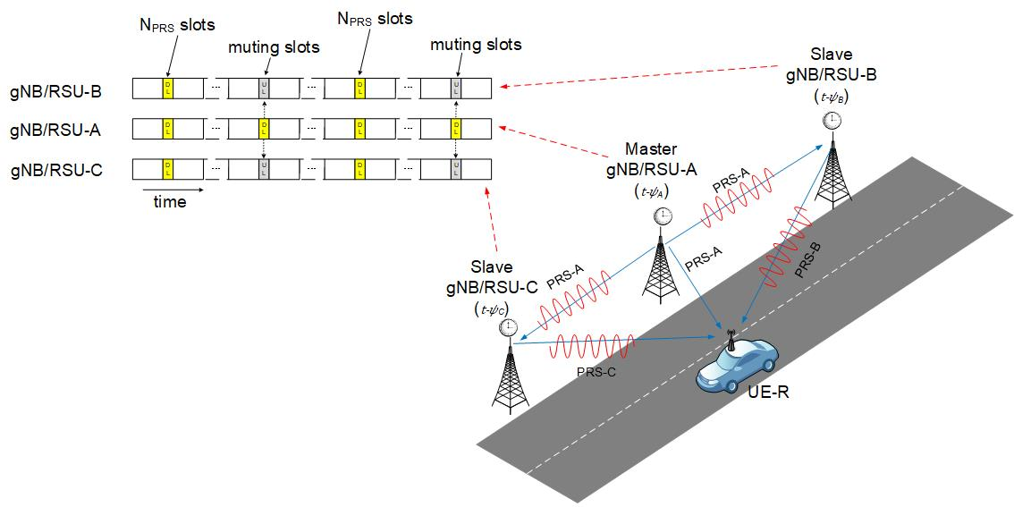

Figure 3 PRS Listening during muting slots in TDD mode

The passband expression of the periodically transmitted PRSA signal by gNB/RSU-A can be represented as equation (10), where ψA represents the local time error of A compared to an absolute time ***t***. ***wc*** is the carrier frequency, and ***w1, w2, ..., wm*** represent the subcarrier frequencies at which the PRSA is deployed. ***A1, A2, ..., Am*** denote the initial phase sequences of each subcarrier constituting the PRSA signal.

(10)

$${PRS}_{Apass}\left(t\right)=\sum_{q=1}^{m}{A_{q}e^{j\left(ω_{c}+ω_{q}\right)\left(t-ψ_{A}\right)}}$$

Similarly, the passband signal of the PRSB signal periodically transmitted by gNB/RSU-B, which is not synchronized in phase, can be expressed as equation (11). ψB represents the local timing error of B.

(11)

$${PRS}_{Bpass}\left(t\right)=\sum_{q=1}^{m}{B_{q}e^{j\left(ω_{c}+ω_{q}\right)\left(t-ψ_{B}\right)}}$$

During the muting interval shown in Figure 3, gNB/RSU-B listens to the PRSA signal transmitted by A, performs down-conversion, and collects the baseband signal samples for FFT analysis. From the extracted phase information, the local timing difference *εBA* between A and B can be measured using equation (12). The detailed derivation of this equation is explained in Appendix-B.

(12)

$$ε_{BA}=ψ_{B}-ψ_{A}=\frac{arg\left(sum\left(Y_{B}\right)\right)+2πN_{cB}}{ω_{c}+ω_{∆}}+τ_{AB}$$

The *εBA* in equation (12) represents the difference in local time between gNB/RSU-B and A. ***tAB*** denotes the signal propagation delay between gNB/RSU-A and B, and ***2πNcB*** is the unknown integer number, which can be resolved if the time delay ***tAB*** between A and B is known. Refer to Appendix-B for more details.

Rotating the PRSB signal phase by the amount of *εBA*, the passband signal phases of A and B can be synchronized. Equation (13) shows a ***curl-vector*** used for rotating the PRSB signal.

(13)

$${curlvect}_{BA}={\left[\begin{aligned}e^{j\left(ω_{c}+ω_{1}\right)ε_{BA}} \\ e^{j\left(ω_{c}+ω_{2}\right)ε_{BA}} \\ ⋮ \\ e^{j\left(ω_{c}+ω_{m}\right)ε_{BA}}\end{aligned}\right]}^{T}={\left[\begin{aligned}e^{j\left(ω_{c}+ω_{1}\right)\left(ψ_{B}-ψ_{A}\right)} \\ e^{j\left(ω_{c}+ω_{2}\right)\left(ψ_{B}-ψ_{A}\right)} \\ ⋮ \\ e^{j\left(ω_{c}+ω_{m}\right)\left(ψ_{B}-ψ_{A}\right)}\end{aligned}\right]}^{T}$$

By taking the inner product of the ***curl-vector*** from equation (13) and the PRSB signal vector, we may obtain the phase-rotated PRSB signal as Equation (14) below.

(14)

$${PRS}_{Bturn}\left(t\right)={curlvect}_{BA}∙\left[\begin{aligned}B_{1}e^{jω_{1}\left(t-ψ_{B}\right)} \\ B_{2}e^{jω_{2}\left(t-ψ_{B}\right)} \\ ⋮ \\ B_{m}e^{jω_{3}\left(t-ψ_{B}\right)}\end{aligned}\right]={\left[\begin{aligned}e^{j\left(ω_{c}+ω_{1}\right)\left(ψ_{B}-ψ_{A}\right)} \\ e^{j\left(ω_{c}+ω_{2}\right)\left(ψ_{B}-ψ_{A}\right)} \\ ⋮ \\ e^{j\left(ω_{c}+ω_{m}\right)\left(ψ_{B}-ψ_{A}\right)}\end{aligned}\right]}^{T}∙\left[\begin{aligned}B_{1}e^{jω_{1}\left(t-ψ_{B}\right)} \\ B_{2}e^{jω_{2}\left(t-ψ_{B}\right)} \\ ⋮ \\ B_{m}e^{jω_{3}\left(t-ψ_{B}\right)}\end{aligned}\right]$$

$$=\sum_{q=1}^{m}{B_{q}e^{j\left(ω_{q}\left(t-ψ_{A}\right)+ω_{c}\left(ψ_{B}-ψ_{A}\right)\right)}}$$

When the phase-rotated PRSB signal in Equation (14) is up-converted to the carrier frequency at the RF frontend, the carrier phase of TRP-B signal becomes identical to A. Compare Equation (15) with Equation (10). This is because the ***curl-vector*** in Equation (13) pre-rotates the phase of PRSB by the initial phase offset between A and B.

(15)

$${PRS}_{Bpass}\left(t\right)=e^{jω_{c}\left(t-ψ_{B}\right)}∙\sum_{q=1}^{m}{B_{q}e^{j\left(ω_{q}\left(t-ψ_{A}\right)+ω_{c}\left(ψ_{B}-ψ_{A}\right)\right)}}=\sum_{q=1}^{m}{B_{q}e^{j\left(ω_{c}+ω_{q}\right)\left(t-ψ_{A}\right)}}$$

In conclusion, by using the ***curl-vector*** to rotate the phase, the PRS reference signals are synchronized in terms of carrier phase. Figure 4 demonstrates the synchronization effect of TRPs using the ***curl-vector***. In Figure 4 (a), the PRS signals of the two drifting TRPs are not phase-synchronized. However, after applying the ***curl-vector*** for phase synchronization, as shown in Figure 4 (b), the phases of the PRS signals remain constant and aligned.

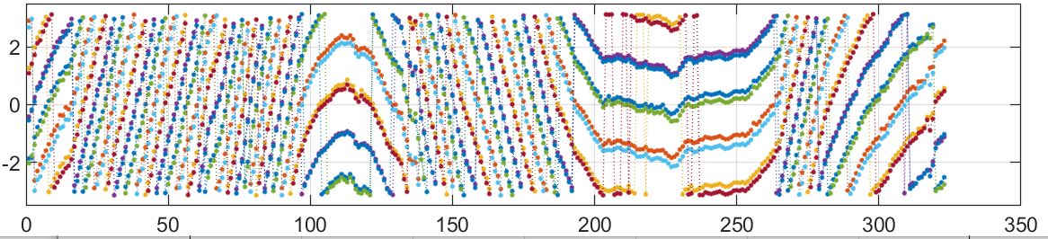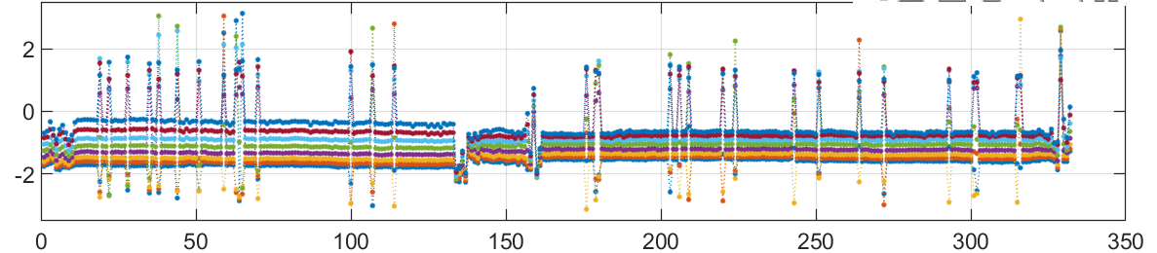

Figure 4 (a) GPSDO synchronization (b) Master-Slave synchronized using continuous PRS

**(Proposal 3) For TRPs operating in TDD mode, support listening of PRS signal transmitted by neighboring TRPs during muting period, calculate the local timing difference, and use it to synchronize the PRS phases of the TRPs.**

**FFS: TRP listening of PRS in FDD mode.**

**(Proposal 4) Supports the transmission of phase rotated PRS using the *curl-vector* to compensate the initial phase offset error between TRPs.**

**4. Carrier phase-based round-trip measurement**

At the last #112bis-e meeting, RAN1 decided to discuss the round trip carrier phase measurement method as below.

* *For carrier phase positioning measurement, RAN1 considers providing measurements for round-trip carrier phase measurement.*

Applying the CPP method to V2X measurements is expected to provide the high precision required by the vehicle industry, even with a regulatory bandwidth of only tens of MHz in the FR1 range.

This section presents one method of CPP measurement for sidelink positioning between vehicles by utilizing reciprocal PRS signal. We propose to use the new terminology RTP (Return Trip Phase) in this contribution, rather than RTT (Return Trip Time) as it calculates the signal phase in the frequency domain to determine the distance and latency.

**(Proposal 5) Introduce a new definition of carrier phase based RTT method, e.g RTP (Return Trip Phase), to avoid confusion with legacy RTT method.**

Figure 5 below illustrates a single/double-sided RTP method in which the V2X UE-B communicates a returning signal with UE-A.

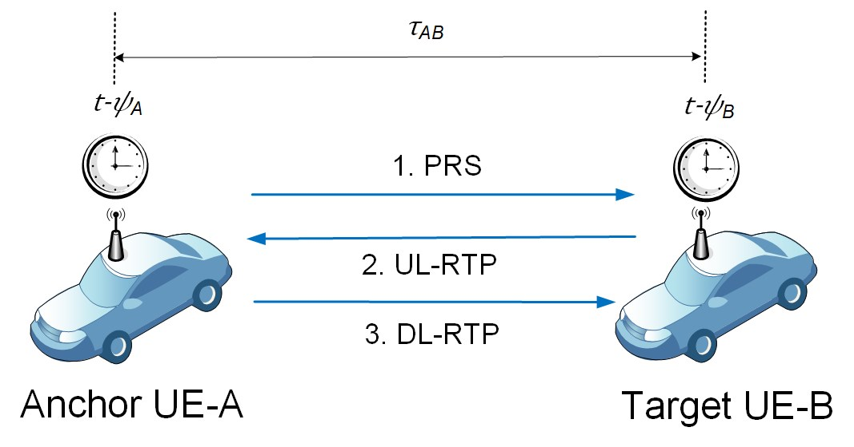

Figure 5 Single/Double-sided RTP method between two vehicles

In Figure 5, the internal clock signal of UE-A and UE-B are generated by unsynchronized local oscillators, which results in their local time being represented as (*t-ψA*) and (*t-ψB*) respectively. UE-A may transmit PRSA signal periodically.

The single-side RTP method can be achieved by the UE-B receiving the PRSA signal of UE-A, replicating the PRSA signal phase and returning it as shown in Figure 6 below. The local clock errors of UE-A and UE-B can be removed during the TX-RX process.

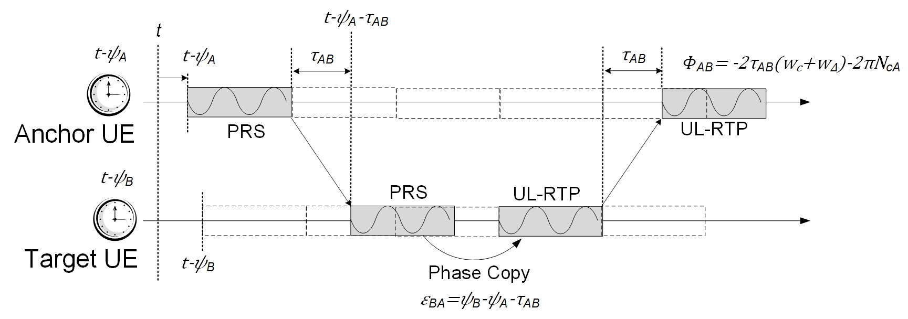

Figure 6 Timing diagram of sing-sided RTP process between V2X UE-A and UE-B

The PRSA signal received by UE-B is decomposed by FFT. It can be expressed in the vector form as shown in (16) below. A detailed mathematical derivation can be found in Appendix-C.

(16)

$$Y_{B}=N∙\left[\begin{aligned}A_{1}e^{j\left(ω_{c}+ω_{1}\right)\left(ψ_{B}-ψ_{A}-τ_{AB}\right)} \\ A_{2}e^{j\left(ω_{c}+ω_{2}\right)\left(ψ_{B}-ψ_{A}-τ_{AB}\right)} \\ ⋮ \\ A_{m}e^{j\left(ω_{c}+ω_{m}\right)\left(ψ_{B}-ψ_{A}-τ_{AB}\right)}\end{aligned}\right]+σ_{B}$$

In above equation (16), ***wc*** is the carrier frequency, ***w1, w2, … wm*** represent the angular frequencies of subcarriers that are equally spaced in the frequency domain. ***A1, A2, … Am*** represent the initial phase sequence of each subcarrier that makes up the PRSA signal. It can be removed if the UE-B knows the sequence. ***tAB*** is the signal propagation delay between UE-A and UE-B. *σB* represents the residual error that remains after the FFT computation. For simplicity, we do not model multipath channel equation in (16).

The UE-B normalizes the complex vector ***YB*** and uses it as a ***curl-vector*** for rotating it’s own PRSB signal,

as described in section 3 above. The phase rotation of PRSB signal is achieved by inner product with normalized ***YB*** vector, as in Equation (17) below.

(17)

$${UL_RTP}_{B}\left(t\right)={\left[\begin{aligned}e^{j\left(ω_{c}+ω_{1}\right)\left(ψ_{B}-ψ_{A}-τ_{AB}\right)} \\ e^{j\left(ω_{c}+ω_{2}\right)\left(ψ_{B}-ψ_{A}-τ_{AB}\right)} \\ ⋮ \\ e^{j\left(ω_{c}+ω_{m}\right)\left(ψ_{B}-ψ_{A}-τ_{AB}\right)}\end{aligned}\right]}^{T}∙\left[\begin{aligned}B_{1}e^{jω_{1}\left(t-ψ_{B}\right)} \\ B_{2}e^{jω_{2}\left(t-ψ_{B}\right)} \\ ⋮ \\ B_{m}e^{jω_{3}\left(t-ψ_{B}\right)}\end{aligned}\right]$$

$$=\sum_{q=1}^{m}{B_{q}e^{j\left(ω_{q}\left(t-ψ_{A}-τ_{BA}\right)+ω_{c}\left(ψ_{B}-ψ_{A}-τ_{AB}\right)\right)}}$$

The UL-RTPB signal, which is the phase is rotated PRSB signal, is up-converted to the carrier frequency ***wc*** and transmitted to UE-A. We assume the up-down link channel is receiprocal.

When UE-A receives the UL-RTPB signal, it down-converts and decomposed signal as shown in (18) below. Again, detail of the transmission and reception process with equations are described in Appendix-C.

(18)

$$Y_{A}=N∙\left[\begin{aligned}B_{1}e^{-j\left(ω_{c}+ω_{1}\right)2τ_{AB}} \\ B_{2}e^{-j\left(ω_{c}+ω_{2}\right)2τ_{AB}} \\ ⋮ \\ B_{m}e^{-j\left(ω_{c}+ω_{m}\right)2τ_{AB}}\end{aligned}\right]+σ_{A}$$

After removing the initial phase sequence value ***B1, B2, … Bm*** , the vector elements in (18) become almost identical except the subcarrier frequency part ***w1, w2, … wm*** . We may apply complex sum of the vector elements and ***arg(…)***function (i.e. ***angle*** function) to extract carrier phase information, as (19) below.

(19)

$$arg\left(sum\left(Y_{A}\right)\right)≅arg\left(e^{-j\left(ω_{c}+ω_{∆}\right)2τ_{AB}}\right)=-\left(ω_{c}+ω_{∆}\right)2τ_{AB}-2πN_{cA}$$

In above Equation (19), ***NcA*** is the integer number to solve. Using the solution explained in Appendix-A, we may estimate this integer number as below (20)

(20)

$$N_{cA}=\left\lfloor \frac{\left(ω_{c}+ω_{∆}\right)}{ω_{g}}\frac{{ΔΦ}_{m-1}}{2π}-\frac{{ΔΦ}_{c}}{2π}\right\rfloor$$

In the above equation (20) , ⌊ ⌋ denotes the integer number truncation function, ***wg*** is the subcarrier frequency and ΔΦm-1 is the measured subcarrier phase, and ***wc*** is the carrier frequency and ΔΦc is the measured carrier phase.

The estimated integer number ***NcA*** can be applied to (19), and rearranging the equation gives the solution for ***tAB*** as (21) below.

(21)

$$τ_{AB}=\frac{arg\left(sum\left(Y_{A}\right)\right)+2πN_{cA}}{ω_{c}+ω_{∆}}$$

UE-A may further implement a double-sided RTP procedure by encoding the calculated time delay information ***tAB*** into another downlink RTP signal. This process will be discussed in next contribution.

**(Oservation 3) The standalone method can also be applied to determine the unknown integer number of carrier phase-based RTP methods using subcarrier information.**

**(Proposal 6) To support the carrier phase-based RTP method for sidelink positioning, copy and transmit function of received PRS signal phase should be considered.**

# Conclusion

We propose the observation and proposal presented in this document as following.

## Observations

**(Observation 1) The standalone approach which utilizes subcarrier information can provide the complete solution of an unknown integer number.**

**(Observation 2) By applying the standalone method, we can obtain a unique solution to the integer ambiguity and perform CPP efficiently. Therefore, it is necessary to support the reporting of multiple subcarrier phase or phase difference information.**

**(Oservation 3) The standalone method can also be applied to determine the unknown integer number of carrier phase-based RTP methods using subcarrier information.**

## Proposals

**(Proposal 1) Support the standalone approach for integer ambiguity which uses multiple subcarrier phase information.**

**(Proposal 2) *For resolving integer ambiguity, subject to UE’s capability, support LMF to request a UE reporting mean value of carrier phase differentials across N subcarriers within a PFL.***

* ***FFS: the value(s) of N***
* ***Note: The initial reference for the carrier phase differentials is a reported RSCP.***

**(Proposal 3) For TRPs operating in TDD mode, support listening of PRS signal transmitted by neighboring TRPs during muting period, calculate the local timing difference, and use it to synchronize the PRS phases of the TRPs.**

**FFS: TRP listening of PRS in FDD mode.**

**(Proposal 4) Supports the transmission of phase rotated PRS using the *curl-vector* to compensate the initial phase offset error between TRPs.**

**(Proposal 5) Introduce a new definition of carrier phase based RTT method, e.g RTP (Return Trip Phase), to avoid confusion with legacy RTT method.**

**(Proposal 6) To support the carrier phase-based RTP method for sidelink positioning, copy and transmit function of received PRS signal phase should be considered.**

# References

|  |  |
| --- | --- |
| [1] | draft TR38.859 v0.2.0, Study on expanded and improved NR positioning (Release 18), RAN1, August, 2022 |
| [2] | 3GPP R1-2104880 , "Carrier/Subcarrier Phase Based Enhancement for 5G NR Positioning " , Dankook University , RAN WG1 #105-e e-Meeting, May 10th – 27th, 2021 |
| [3] | 3GPP R1-2104844 , "Carrier Phase Based Downlink Angle of Departure Measurement" , Dankook University , RAN WG1 #105-e e-Meeting, May 10th – 27th, 2021 |
| [4] | 3GPP R1-2101470 , " Potential Enhancements on DL-AoD positioning " , Qualcomm Incorporated , RAN WG1 #104-e e-Meeting, January 25th – February 5th, 2021 |
| [5] | 3GPP R1-2211259, "Experiment and simulation result on carrier phase based positioning" , Locaila, RAN WG1 #111, Nov 14 – Nov 18, 2022 |
| [6] | 3GPP R1-2203635, "Continuous PRS for improved carrier phase measurement" , Dankook University , RAN WG1 #109-e e-Meeting, May 9th – 20th, 2022 |
| [7] | 3GPP R1-2203635, "Continuous PRS for improved carrier phase measurement" , Dankook University , RAN WG1 #109-e e-Meeting, May 9th – 20th, 2022 |
| [8] | 3GPP R1-2206227, "Solution for Integer Ambiguity, TRP synchronization and Vertical Positioning" , Locaila, RAN WG1 #110, Aug 22 – Aug 26, 2022 |
| [9] | 3GPP R1-2303279 , "Discussion on carrier phase positioning", ZTE, RAN WG1 #112bin-e e-meeting, April 17th - 26th, 2023 |
| [10] | 3GPP R1-2302934 , "Views on NR DL and UL carrier phase positioning", Nokia, Nokia Shanghai Bell , RAN WG1 #112bis-e e-meeting, April 17 - 26th, 2023 |
| [11] | 3GPP R1-2302711 , "Further discussion on NR DL and UL carrier phase positioning", CATT, RAN WG1 #112bis-e e-meeting, April 17th – April 26th, 2023 |
| [12] | 3GPP R1-2303774 , "Discussion on integer number solutions", Locaila , RAN WG1 #112bis-e e-Meeting, April 17th – April 26th, 2023 |
| [13] | 3GPP R1-2303775 , "Solution for Carrier Phase based RTT Positioning" , Locaila , RAN WG1 #112bis-e , e-Meeting, April 17th – April 26th, 2023 |
|  |  |
|  |  |

**Appendix-A Exact Solution for Integer Number Estimation**

Finding the integer number for carrier phase is relatively simple in OFDM system because there’s an integer multiple relationship between carrier and subcarrier wavelengths.

For example, let the frequency of a subcarrier number ***q*** is ***fq*** *Hz*, and the carrier frequency that modulates and transmits it is ***fc*** *Hz*. If 𝕔 is the speed of light, the subcarrier wavelength is (𝕔/ ***fq***) meter, which is (***fc*** / ***fq***) times the carrier wavelength.

Suppose two transmitting and receiving UEs A and B are now calculating the distance by measuring the carrier phase as well as the subcarrier phase of a PRS signal. We assume the subcarrier ***q*** is the longest subcarrier consisting the PRS signal. If the distance between the UE-A and UE-B is less than 1/2 times the subcarrier wavelength (𝕔/ ***fq***) meter, then we can uniquly measure the distance using the subcarrier wavelength without ambiguity. Let ***tAB*** is the propagation delay between A and B, and 𝜙s is the measured subcarrier phase. Then the subcarrier phase can be represented as (A1).

(A1)

$$ϕ_{s}=f_{q}τ_{AB} , τ_{AB}=\frac{ϕ_{s}}{f_{q}}$$

Simularily, the carrier phase 𝜙c measured using the PRS can be represented as (A2) below.

(A2)

$$ϕ_{c}=f_{c}τ_{AB}-2πN$$

In Equation (A2), ***N*** is the unknown integer number to solve. Substituting ***tAB*** in Equation (A2) into (A1), and rearranging the equation for the integer number ***N*** gives the integer number estimation equation (A3).

(A3)

$$N=\left\lfloor f_{c}/f_{q}∙ϕ_{s}/2π-ϕ_{c}/2π\right\rfloor$$

In the above equation (A3), ⎿⏌ denotes an integer number conversion function, (***fc*** / ***fq***) is the integer multiple ratio of the carrier wavelength divided by the subcarrier wavelength. 𝜙s/2𝜋 and 𝜙c/2𝜋 are normalized carrier and subcarrier phase value in the range of 0~1 (or -0.5 ~ +0.5).

The Equation (A3) is non-iterative, deterministic solution, which allows to determine both the UE's initial position as well as the unknown integer number without the help of the legacy positioning method.

**Appendix-B Mathmatical Derivation of TRP synchronization using PRS phase signal**

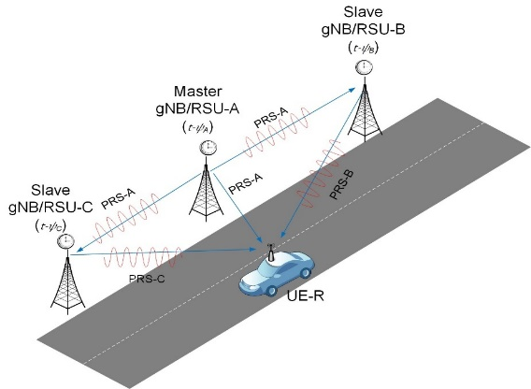

Figure B1. PRS transmission and listening between neighboring gNB/RSUs

In Figure B1 above, the TRP A, B, and C each have a local timing error of ***(t-ψA), ( t-ψB), (t-ψC)*** compared to the absolutely correct time ***t***. The ***PRSA*** reference signal periodically transmitted by gNB/RSU-A can be expressed as (B1). This PRS signal is the same reference signal used in TDoA or AoA.

(B1)

$${PRS}_{A}\left(t\right)=A_{1}e^{jω_{1}\left(t-ψ_{A}\right)}+A_{2}e^{jω_{2}\left(t-ψ_{A}\right)}+…+A_{m}e^{jω_{m}\left(t-ψ_{A}\right)}=\sum_{q=1}^{m}{A_{q}e^{jω_{q}\left(t-ψ_{A}\right)}}$$

In Equation (B1), ***w1 , w2 , . . . wm*** means the angular frequencies of subcarriers arranged at equal distances in the frequency domain. The comb-N structure of Rel-17 PRS can also be seen as a form of such an equidistant subcarrier arrangement. The gap frequency between the subcarriers is ***wg***, as calculated by Equation (B2).

(B2)

***A1, A2, … Am*** means the initial phase sequence of each subcarrier constituting the PRS signal. This initial phase sequence is applied for purposes such as reducing PAPR, and it can be removed if the receiver knows this sequence.

The ***PRSB*** and ***PRSC*** reference signals transmitted by the gNB/RSU-B and C respectively can be expressed as follows.

(B3)

$${PRS}_{B}\left(t\right)=\sum_{q=1}^{m}{B_{q}e^{jω_{q}\left(t-ψ_{B}\right)}}$$

$${PRS}_{C}\left(t\right)=\sum_{q=1}^{m}{C_{q}e^{jω_{q}\left(t-ψ_{C}\right)}}$$

From the above (B1) and (B3), we can see that the phases of the ***PRSA, PRSB***, and ***PRSC*** reference signals are all different because the local clock is not synchronized.

For simplicity of description, it is assumed that TRP-A, B, and C all transmit PRSs using the same ***m*** subcarrier set in a time division method. However, they may be multiplexed and transmitted over different subcarriers within the same time slot.

The baseband PRS signal in Equation (B1) above is modulated (i.e. multiplied) to the carrier frequency ***wc*** at the RF frontend of the transmitter ***A*** as in Equation (B4) below.

(B4)

$${PRS}_{Apass}\left(t\right)=e^{jω_{c}\left(t-ψ_{A}\right)}∙{PRS}_{A}\left(t\right)=\sum_{q=1}^{m}{A_{q}e^{j\left(ω_{c}+ω_{q}\right)\left(t-ψ_{A}\right)}}$$

Note that *ψA* is the local clock error of gNB/RSU-A. The signal reaches neighboring gNB/RSU-B after propagation delay ***tAB***. This can be expressed as Equation (B5) below. For simplicity, we do not describe the multipath channel equation in (B5) but only show the signal propagation delay ***tAB*** over an LoS path.

(B5)

$${PRS}_{Ach}\left(t\right)=e^{-j\left(ω_{c}+ω_{q}\right)τ_{AB}}∙{PRS}_{Apass}\left(t\right)=\sum_{q=1}^{m}{A_{q}e^{j\left(ω_{c}+ω_{q}\right)\left(t-ψ_{A}-τ_{AB}\right)}}$$

The gNB-B down-converts the passband ***PRSA*** signal by mixing the reverse carrier frequency -***wc***. This is expressed in Equation (B6) below. The local clock error of gNB/RSU-B is *ψB*.

(B6)

$$y_{B}\left(t\right)=e^{-jω_{c}\left(t-ψ_{B}\right)}∙{PRS}_{Ach}\left(t\right)=\sum_{q}{A_{q}e^{j\left(ω_{c}\left(ψ_{B}-ψ_{A}-τ_{AB}\right)+ω_{q}\left(t-ψ_{A}-τ_{AB}\right)\right)}}$$

gNB/RSU-B collects the baseband signal samples of Equation (B6) above, applies FFT, and extracts the PRS subcarrier ***w1, w2, … wm*** in the frequency domain. This can be expressed in the vector form of Equation (B7).

(B7)

$$Y_{BA}=N∙\left[\begin{aligned}A_{1}e^{j\left(ω_{c}+ω_{1}\right)\left(ψ_{B}-ψ_{A}-τ_{AB}\right)} \\ A_{2}e^{j\left(ω_{c}+ω_{2}\right)\left(ψ_{B}-ψ_{A}-τ_{AB}\right)} \\ ⋮ \\ A_{m}e^{j\left(ω_{c}+ω_{m}\right)\left(ψ_{B}-ψ_{A}-τ_{AB}\right)}\end{aligned}\right]+σ_{BA}$$

The subcarrier vector ***YBA*** in Equation (B7) above contains both local clock error (*ψB-ψA*) and path delay ***tAB*** information. *σBA* represents the residual error component that occurs during the FFT process. The initial phase sequences of the ***PRSA*** signal are *A1, A2, … Am*. If this is known by gNB-B, it can be removed from the ***YBA*** vector in Equation (B7).

Summing up the ***YBA*** vector elements of complex numbers, and applying the *arc-tangent (i.e. angle)* function, we may obtain the carrier phase equation as (B8) below.

(B8)

$$arg\left(sum\left(Y_{BA}\right)\right)≅arg\left(e^{j\left(ω_{c}+ω_{∆}\right)\left(ψ_{B}-ψ_{A}-τ_{AB}\right)}\right)=\left(ω_{c}+ω_{∆}\right)\left(ψ_{B}-ψ_{A}-τ_{AB}\right)-2πN_{cB}$$

In Equation (B8), ***wc*** is the carrier frequency, and ***wΔ*** is the median of the subcarrier array ***w1, w2, … wm***. Note that (*wc* + *wΔ*) in equation (B8) is a very large number, but the ***arg(...)*** function only returns values between the range -π ~ +π. Therefore, it is necessary to estimate and compensate for the unknown integer number ***NcB*** to recover the lost phase cycles. This is a well-known Integer Ambiguity problem.

If the positions of the TRPs are fixed and the signal delay ***tAB*** between them is known, we can calculate the unknown integer number by applying Equation (B9) below. The⎿⏌ denotes an integer number conversion function.

(B9)

$$N_{cB}=\left\lfloor \left(ω_{c}+ω_{∆}\right)τ_{AB}/2π\right\rfloor$$

Applying the number ***NcB*** to Equation (B8) above, gNB-B can calculate *εBA* as below (B10), which is the difference between the local clock errors of ***A*** and ***B***.

(B10)

$$ε_{BA}=ψ_{B}-ψ_{A}=\frac{arg\left(sum\left(Y_{BA}\right)\right)+2πN_{cB}}{ω_{c}+ω_{∆}}+τ_{AB}$$

Rotating the PRSB signal phase by the amount of *εBA*, the passband signal phases of A and B can be synchronized. Equation (B11) shows a ***curl-vector*** used for rotating the PRSB signal.

(B11)

$${curlvect}_{BA}={\left[\begin{aligned}e^{j\left(ω_{c}+ω_{1}\right)ε_{BA}} \\ e^{j\left(ω_{c}+ω_{2}\right)ε_{BA}} \\ ⋮ \\ e^{j\left(ω_{c}+ω_{m}\right)ε_{BA}}\end{aligned}\right]}^{T}={\left[\begin{aligned}e^{j\left(ω_{c}+ω_{1}\right)\left(ψ_{B}-ψ_{A}\right)} \\ e^{j\left(ω_{c}+ω_{2}\right)\left(ψ_{B}-ψ_{A}\right)} \\ ⋮ \\ e^{j\left(ω_{c}+ω_{m}\right)\left(ψ_{B}-ψ_{A}\right)}\end{aligned}\right]}^{T}$$

By taking the inner product of the ***curl-vector*** from equation (B11) and the PRSB signal vector, we may obtain the phase-rotated PRSB signal as Equation (B12) below.

(B12)

$${PRS}_{Bturn}\left(t\right)={curlvect}_{BA}∙\left[\begin{aligned}B_{1}e^{jω_{1}\left(t-ψ_{B}\right)} \\ B_{2}e^{jω_{2}\left(t-ψ_{B}\right)} \\ ⋮ \\ B_{m}e^{jω_{3}\left(t-ψ_{B}\right)}\end{aligned}\right]={\left[\begin{aligned}e^{j\left(ω_{c}+ω_{1}\right)\left(ψ_{B}-ψ_{A}\right)} \\ e^{j\left(ω_{c}+ω_{2}\right)\left(ψ_{B}-ψ_{A}\right)} \\ ⋮ \\ e^{j\left(ω_{c}+ω_{m}\right)\left(ψ_{B}-ψ_{A}\right)}\end{aligned}\right]}^{T}∙\left[\begin{aligned}B_{1}e^{jω_{1}\left(t-ψ_{B}\right)} \\ B_{2}e^{jω_{2}\left(t-ψ_{B}\right)} \\ ⋮ \\ B_{m}e^{jω_{3}\left(t-ψ_{B}\right)}\end{aligned}\right]$$

$$=\sum_{q=1}^{m}{B_{q}e^{j\left(ω_{q}\left(t-ψ_{A}\right)+ω_{c}\left(ψ_{B}-ψ_{A}\right)\right)}}$$

The baseband samples of ***PRSB*** in Equation (B12) above are mixed with the carrier frequency ***wc*** at the RF frontend and transmitted on the air as shown in Equation (B13) below. Note that the local timing error of B is (*t-ψB*). However, when the carrier frequency is multiplied, the clock error *ψB* is replaced by *ψA* which is the clock error of A. As a result, the passband signal phase of ***PRSB*** becomes identical to ***PRSA***.

(B13)

$${PRS}_{Bpass}\left(t\right)=e^{jω_{c}\left(t-ψ_{B}\right)}∙{PRS}_{B}\left(t\right)=e^{jω_{c}\left(t-ψ_{B}\right)}∙\sum_{q=1}^{m}{B_{q}e^{j\left(ω_{q}\left(t-ψ_{A}\right)+ω_{c}\left(ψ_{B}-ψ_{A}\right)\right)}}$$

$$∴{PRS}_{Bpass}\left(t\right)=\sum_{q=1}^{m}{B_{q}e^{j\left(ω_{c}+ω_{q}\right)\left(t-ψ_{A}\right)}}$$

**Appendix-C Mathmatical Derivation of Carrier Phase Based Return Trip Method**

Figure C1 below illustrates a single/double-sided RTP method in which the target UE-B communicates a returning signal with anchor UE-A.



Figure C1. Single/Double-sided RTP method between two vehicles

In Figure C1, the internal clock signal of anchor UE-A and target UE-B are generated by unsynchronized local oscillators, which results in their local time being represented as (*t-ψA*) and (*t-ψB*) respectively. While the local clock errors *ψA* and *ψB* can be changed slightly over time, for convenience, instantaneous time errors are assumed to be fixed constants.

The RTP procedure begins with UE-A periodically broadcasting the PRS signal generated by Equation (C1) below. This PRS signal is the same reference signal used in methods such as TDoA or AoA.

(C1)

$${PRS}_{A}\left(t\right)=A_{1}e^{jω_{1}\left(t-ψ_{A}\right)}+A_{2}e^{jω_{2}\left(t-ψ_{A}\right)}+…+A_{m}e^{jω_{m}\left(t-ψ_{A}\right)}=\sum_{q=1}^{m}{A_{q}e^{jω_{q}\left(t-ψ_{A}\right)}}$$

In Equation (C1), ***w1, w2, … wm*** represent the angular frequencies of subcarriers that are equally spaced in the frequency domain. The legacy comb-N structure can also be viewed as a form of equal spacing of subcarriers. ***A1, A2, … Am*** represent the initial phase sequence of each subcarrier that makes up the PRS signal.

The PRS signal can be transmitted periodically at ***k*** times of a slot interval. If the initial phase sequences ***A1, A2, … Am*** for each iteration cycle remain unchanged, we can see that the same PRS waveform repeats every ***k*** times the slot length ***L***, as shown in Equation (C2).

(C2)

$${PRS}_{A}\left(t\right)={PRS}_{A}\left(t+kL\right) , L=slot length$$

In the above (C2), ***L*** denotes the length of a slot, and ***k*** is the PRS iteration cycle. The implication is that the phase value of the PRS signal measured at the time (***t+kL***) for any ***k*** value is equal to the phase value measured at time ***t***. In other words, when applying the phase-based measurement method, which operates on a slot basis, all signals measured at different slot times can be considered to be measured at the same time ***t***, hence the phase comparison can be made regardless of the slot location. Therefore, relative time can be measured more flexibly and conveniently than the RTT method.

The baseband PRS signal in Equation (C1) above is mixed with the carrier signal of frequency ***wc*** at the RF frontend of the transmitter, and modulated into the passband signal in Equation (C3) below.

(C3)

$${PRS}_{Apass}\left(t\right)=e^{jω_{c}\left(t-ψ_{A}\right)}∙{PRS}_{A}\left(t\right)=\sum_{q=1}^{m}{A_{q}e^{j\left(ω_{c}+ω_{q}\right)\left(t-ψ_{A}\right)}}$$

In the above equation (C3), since the local timing error of A is ψA, the same timing offset is applied to the carrier signal and multiplied by (t-ψA).

The passband signal in (C3) above reaches UE-B after the ***tAB*** delay. This can be represented by Equation (C4) below. To simplify the description, equation (C4) does not include a multipath channel expression, but just shows a single transmission delay on a line-of-sight path.

(C4)

$${PRS}_{Ach}\left(t\right)=e^{-j\left(ω_{c}+ω_{q}\right)τ_{AB}}∙{PRS}_{Apass}\left(t\right)=\sum_{q=1}^{m}{A_{q}e^{j\left(ω_{c}+ω_{q}\right)\left(t-ψ_{A}-τ_{AB}\right)}}$$

Looking closely at Equation (C4) above, it can be seen that the PRS signal received from UE-B has a signal phase rotated by the propagation delay ***tAB*** between A-B. The receiver can measure this phase rotation to obtain propagation delay and distance information.

The UE-B multiplies the received passband PRS signal by the inverse carrier frequency to down-conversion. In Equation (C5) below, the local clock error of UE-B is ψB, so the carrier signal is multiplied by (t-ψB).

(C5)

$$y_{B}\left(t\right)=e^{-jω_{c}\left(t-ψ_{B}\right)}∙{PRS}_{Ach}\left(t\right)=\sum_{q}{A_{q}e^{j\left(ω_{c}\left(ψ_{B}-ψ_{A}-τ_{AB}\right)+ω_{q}\left(t-ψ_{A}-τ_{AB}\right)\right)}}$$

UE-B collects the down-converted baseband signal samples of Equation (C5) above and decomposes them using the FFT process. Hence the PRS subcarriers of ***w1, w2, … wm*** is recovered. The recovered PRS subcarriers are shown in the vector form of Equation (C6).

(C6)

$$Y_{B}=N∙\left[\begin{aligned}A_{1}e^{j\left(ω_{c}+ω_{1}\right)\left(ψ_{B}-ψ_{A}-τ_{AB}\right)} \\ A_{2}e^{j\left(ω_{c}+ω_{2}\right)\left(ψ_{B}-ψ_{A}-τ_{AB}\right)} \\ ⋮ \\ A_{m}e^{j\left(ω_{c}+ω_{m}\right)\left(ψ_{B}-ψ_{A}-τ_{AB}\right)}\end{aligned}\right]+σ_{B}$$

The carrier phase vector ***YB*** in Equation (C6) above contains both local clock error (𝜓B - 𝜓A) and path delay ***tAB*** in the exponent part of the complex number. *σB* represents the residual error that remains after the FFT computation.

Note that the carrier phase vector ***YB*** includes the initial phase sequence ***A1, A2, … Am*** of the PRS signal sent by UE-A. It can be removed if the UE-B knows the sequence.

The UE-B rotates the PRSB subcarrier by the amount of received PRSA signal phase and returns it to anchor UE-A. This can be understood conceptually as the UE-B copies and returns the received PRSA signal phase. This phase-rotated PRSB signal is referred to herein as the ***UL_RTPB*** signal.

The ***UL_RTPB*** signal can be expressed in the form of an inner product of the vector (C6) with the PRSB vector of UE-B, as shown in Equation (C7) below.

(C7)

$${UL_RTP}_{B}\left(t\right)={\left[\begin{aligned}e^{j\left(ω_{c}+ω_{1}\right)\left(ψ_{B}-ψ_{A}-τ_{AB}\right)} \\ e^{j\left(ω_{c}+ω_{2}\right)\left(ψ_{B}-ψ_{A}-τ_{AB}\right)} \\ ⋮ \\ e^{j\left(ω_{c}+ω_{m}\right)\left(ψ_{B}-ψ_{A}-τ_{AB}\right)}\end{aligned}\right]}^{T}∙\left[\begin{aligned}B_{1}e^{jω_{1}\left(t-ψ_{B}\right)} \\ B_{2}e^{jω_{2}\left(t-ψ_{B}\right)} \\ ⋮ \\ B_{m}e^{jω_{3}\left(t-ψ_{B}\right)}\end{aligned}\right]$$

$$=\sum_{q=1}^{m}{B_{q}e^{j\left(ω_{q}\left(t-ψ_{A}-τ_{BA}\right)+ω_{c}\left(ψ_{B}-ψ_{A}-τ_{AB}\right)\right)}}$$

The ***UL-RTPB*** reference signal whose phase is rotated in Equation (C7) above is mixed with the carrier frequency ***wc*** as shown in Equation (C8) below to up-convert to a passband signal at the RF terminal of UE-B. Also, the same local timing offset is applied to the carrier signal and multiplied by (t-ψB).

(C8)

$${UL_RTP}_{Bpass}\left(t\right)=e^{jω_{c}\left(t-ψ_{B}\right)}∙\sum_{q=1}^{m}{B_{q}e^{j\left(ω_{q}\left(t-ψ_{A}-τ_{AB}\right)+ω_{c}\left(ψ_{B}-ψ_{A}-τ_{AB}\right)\right)}}$$

$$=\sum_{q=1}^{m}{B_{q}e^{j\left(ω_{c}+ω_{q}\right)\left(t-ψ_{A}-τ_{AB}\right)}}$$

If the up-down channel between A and B is the same (i.e reciprocal), the ***UL_RTPB*** signal arriving at the UE-A after time ***tAB*** can be expressed as (C9) below. Again, to simplify the description, Equation (C9) does not include a multipath channel expression, but just shows a single transmission delay on a line-of-sight path.

(C9)

$${UL_RTP}_{Bch}\left(t\right)=e^{-j\left(ω_{c}+ω_{q}\right)τ_{AB}}∙{UL_RTP}_{Bpass}\left(t\right)$$

$$=e^{-j\left(ω_{c}+ω_{q}\right)τ_{AB}}∙\sum_{q}{B_{q}e^{j\left(ω_{c}+ω_{q}\right)\left(t-ψ_{A}-τ_{AB}\right)}}=\sum_{q=1}^{m}{B_{q}e^{j\left(ω_{c}+ω_{q}\right)\left(t-ψ_{A}-2τ_{AB}\right)}}$$

UE-A down-converts the received passband ***UL-RTPB*** signal. In Equation (C10) below, since the local clock error of UE-A is ψA, the carrier signal is multiplied by (t-ψA) with the same timing offset applied.

(C10)

$$y_{A}\left(t\right)=e^{-jω_{c}\left(t-ψ_{A}\right)}∙{UL_RTP}_{Bch}\left(t\right)=\sum_{q}{B_{q}e^{j\left(ω_{c}\left(-2τ_{AB}\right)+ω_{q}\left(t-ψ_{A}-2τ_{AB}\right)\right)}}$$

The subcarrier vector ***YA*** in Equation (C11) below is obtained by collecting the demodulated baseband signal samples of Equation (10), applying the FFT, and extracting ***m*** subcarrier elements in the frequency domain.

Similar to the case of the PRS reference signal, if the anchor UE-A knows the initial phase sequence *B1, B2, … Bm* of the ***UL-RTPB*** signal, it can be removed.

(C11)

$$Y_{A}=N∙\left[\begin{aligned}B_{1}e^{-j\left(ω_{c}+ω_{1}\right)2τ_{AB}} \\ B_{2}e^{-j\left(ω_{c}+ω_{2}\right)2τ_{AB}} \\ ⋮ \\ B_{m}e^{-j\left(ω_{c}+ω_{m}\right)2τ_{AB}}\end{aligned}\right]+σ_{A}$$

After removing the initial phase sequence value in the vector ***YA***, the carrier phase value is calculated by summing the complex value of each element and applying the ***arg(…)*** function (i.e. ***angle*** function) as (C12) below.

(C12)

$$arg\left(sum\left(Y_{A}\right)\right)≅arg\left(e^{-j\left(ω_{c}+ω_{∆}\right)2τ_{AB}}\right)=-\left(ω_{c}+ω_{∆}\right)2τ_{AB}-2πN_{cA}$$

In above Equation (C12), ***wc*** is the carrier frequency and ***wΔ*** is the median of the subcarriers ***w1, w2, … wm***, and ***NcA*** is unknown integer number.

In order to apply the solution for integer ambiguity explained in Appendix-A, the ***YA*** vector in (C11) is divided into (***m-1***) length upper subvector and (***m-1***) length lower subvector. The two subvectors are conjugate multiplied element-by-element to obtain subcarrier phase of gap frequency ***wg***, which is the longest wavelength subcarrier.

(C13)

$$\left(Y_{A+1}Y_{A-1}^{*}\right)=N∙\left[\begin{aligned}e^{-j\left(ω_{c}+ω_{2}\right)2τ_{AB}} \\ e^{-j\left(ω_{c}+ω_{3}\right)2τ_{AB}} \\ ⋮ \\ e^{-j\left(ω_{c}+ω_{m}\right)2τ_{AB}}\end{aligned}\right]⨁N∙\left[\begin{aligned}e^{j\left(ω_{c}+ω_{1}\right)2τ_{AB}} \\ e^{j\left(ω_{c}+ω_{2}\right)2τ_{AB}} \\ ⋮ \\ e^{j\left(ω_{c}+ω_{m-1}\right)2τ_{AB}}\end{aligned}\right]$$

$$=N^{2}∙\left[\begin{aligned}e^{-j\left(ω_{2}-ω_{1}\right)2τ_{AB}} \\ e^{-j\left(ω_{3}-ω_{2}\right)2τ_{AB}} \\ ⋮ \\ e^{-j\left(ω_{m}-ω_{m-1}\right)2τ_{AB}}\end{aligned}\right]=N^{2}∙\left[\begin{aligned}e^{-2jω_{g}τ_{AB}} \\ e^{-2jω_{g}τ_{AB}} \\ ⋮ \\ e^{-2jω_{g}τ_{AB}}\end{aligned}\right]$$

In Equation (C13) above, ***YA+1*** denotes the lower (***m-1***) length subvector of Equation (11), and ***Y*A-1*** denotes the complex conjugate of the upper (***m-1***) length subvector.

Note that the carrier frequency in Equation (C11) appears in the form of a product of the carrier frequency (***wc + wΔ***), however ***wc*** is removed in Equation (C13) and only the subcarrier frequency ***wg*** (=wm–wm-1 ) remains in the equation. Summing up the vector elements in Equation (C13) and applying the ***arg(…)*** function gives following result of ***tAB***.

(C14)

$$arg\left(sum\left(Y_{A+1}Y_{A-1}^{*}\right)\right)≅arg\left(e^{-2jω_{g}τ_{AB}}\right)=-2ω_{g}τ_{AB}$$

$$∴ τ_{AB}=-\frac{arg\left(sum\left(Y_{A+1}Y_{A-1}^{*}\right)\right)}{2ω_{g}}$$

Note that ***tAB*** in (C14) is only a coarse measurement result using long subcarrier wave. In order to refine the measurement result, subcarrier phase measured in (C14) is applied to equation (C15) below.

(C15)

$$N_{cA}=\left\lfloor \frac{\left(ω_{c}+ω_{∆}\right)}{ω_{g}}\frac{arg\left(sum\left(Y_{A+1}Y_{A-1}^{*}\right)\right)}{2π}-\frac{arg\left(sum\left(Y_{A}\right)\right)}{2π}\right\rfloor$$

Finally, applying the integer number ***NcA*** into (C12) results in the refined carrier phase measurement of propagation delay ***tAB*** .

(C16)

$$τ_{AB}=\frac{arg\left(sum\left(Y_{A}\right)\right)+2πN_{cA}}{ω_{c}+ω_{∆}}$$